SDET Retail App – Selenium + Cucumber Automation framework Report

Objective:
This project automates the process of shopping journey of retail website using Selenium WebDriver and Cucumber BDD framework. The goal was to simulate how a real person interacts and validate functionalities such as product search, checkout and order placement.

User Story:
As a shopper, I want to search the catalog, add products to my cart, and complete checkout. So that I can purchase the products I want.

Technologies Used:
Java, Selenium WebDriver, Cucumber (BDD), Junit, Maven, Allure & Extent reports.

Framework Architecture:
The automation framework was developed using Page Object Model.
The project contains:
- Pages → Contains page actions and locators
- Components → Reusable UI elements such as Header and Cart Badge
- Step Definitions → Contains assertions and test steps
- Hooks → Browser setup, teardown and screenshot capture
- Feature Files → Business readable test scenarios
A shared BasePage was created to avoid repeating common actions like click(), type(), visible(), text(), elements()

Scenarios Implemented:

Positive Test Scenario

- Buy a single product end to end (@smoke)

Validate that a customer can successfully purchase a product.

Open catalog -> Search product -> Add to cart -> Open cart -> Proceed to Checkout -> Confirm order

Result: Passed

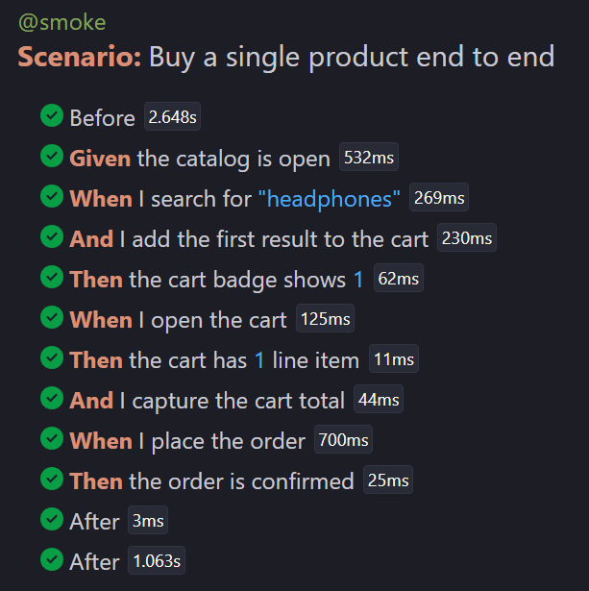

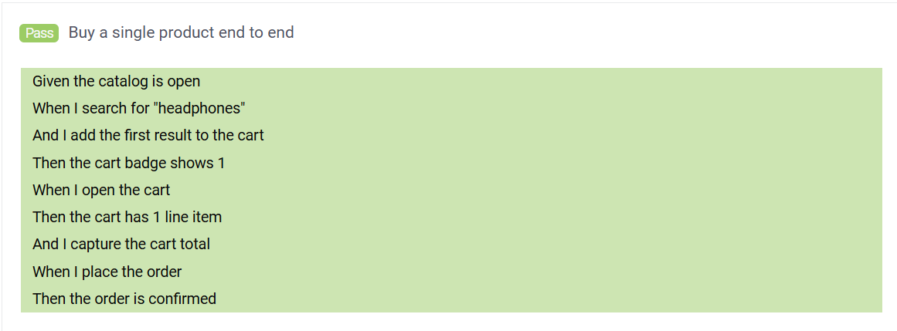

- Cart Badge Reflects Number of Items (@smoke)

Validate that cart badge count updates correctly after adding products.

Search product -> Add to cart -> Verify cart badge

Result: Passed

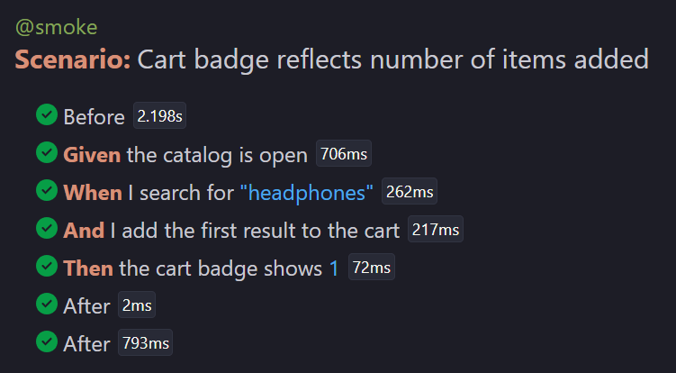

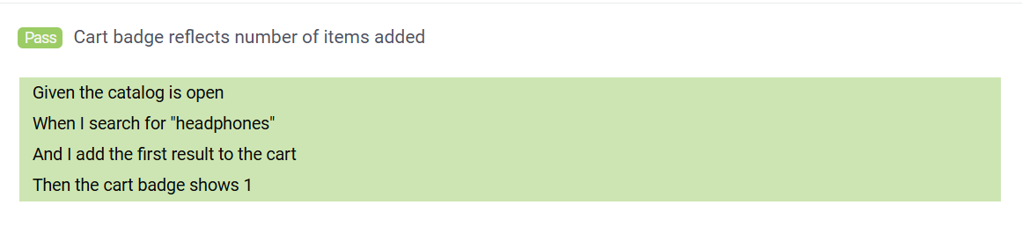

- Purchase Multiple Products Using Scenario Outline (@regression)

Validate purchase flow for different products using a reusable scenario.

Open catalog -> Search product -> Add to cart -> Open cart -> Proceed to Checkout -> Confirm order

Products Tested:
Headphones, Shoes, Lamp, Backpack

Result: Passed
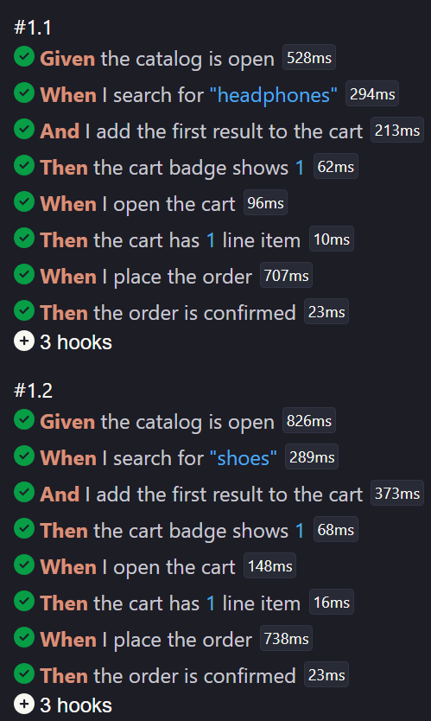
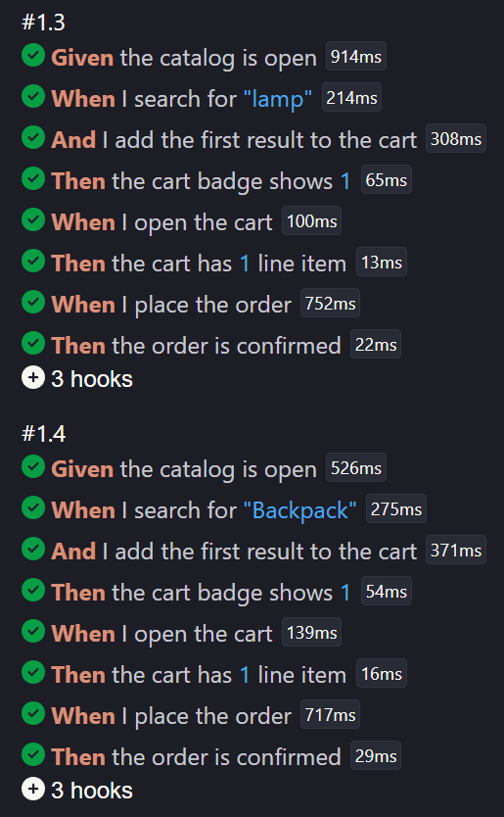
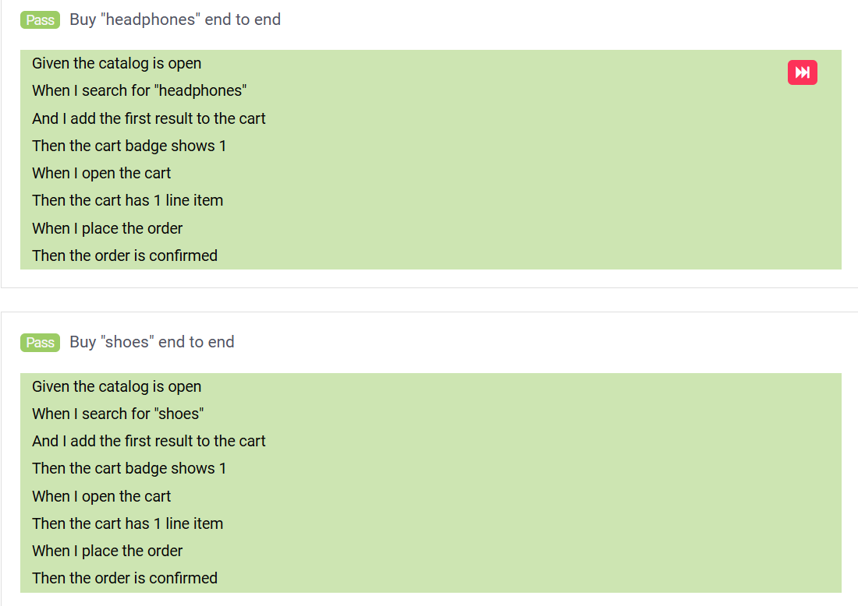
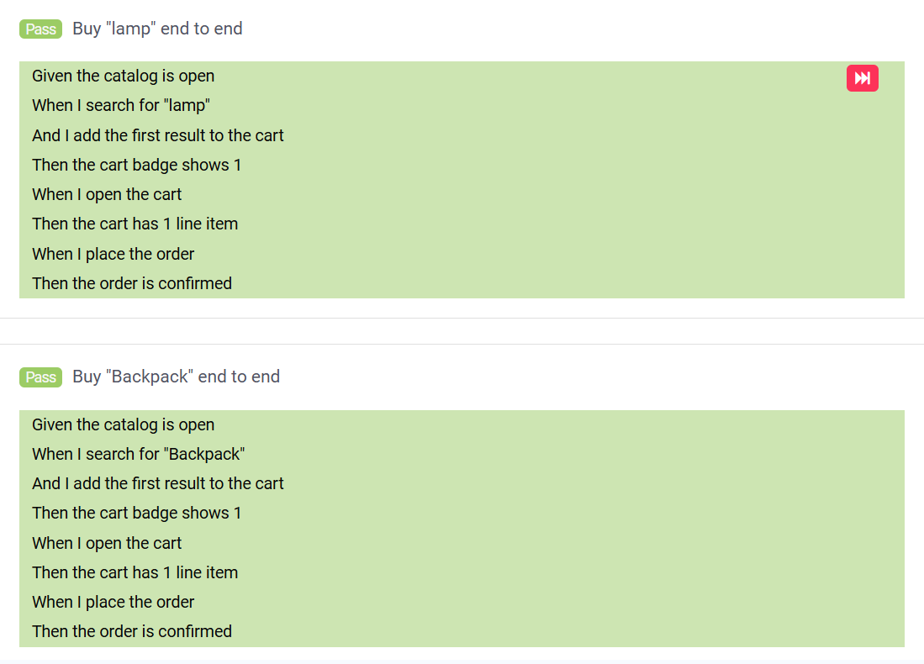

- Fresh Cart Empty Validation (@regression)

Validate that a newly opened cart contains no products.

Open cart -> Verify line item count

Result: Passed

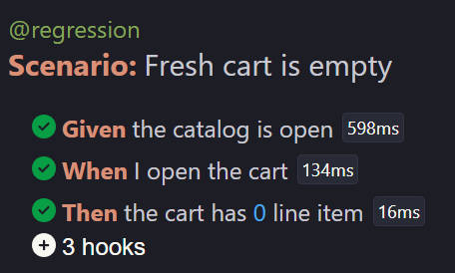

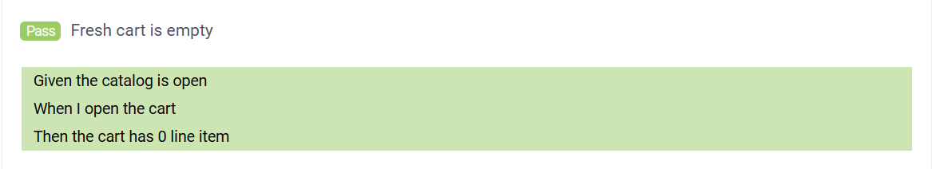

- Customer Login and Purchase Flow (@e2e)

Validate complete customer journey starting from login until order confirmation.

Open login page -> Login using valid credentials -> Open catalog -> Search product -> Add to cart -> Checkout -> Confirm order

Test User:
Email: customer@example.com
Password: Password@123

Result: Passed

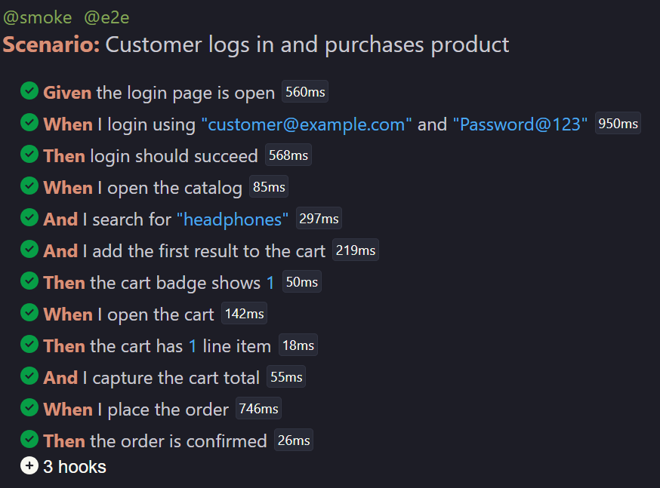

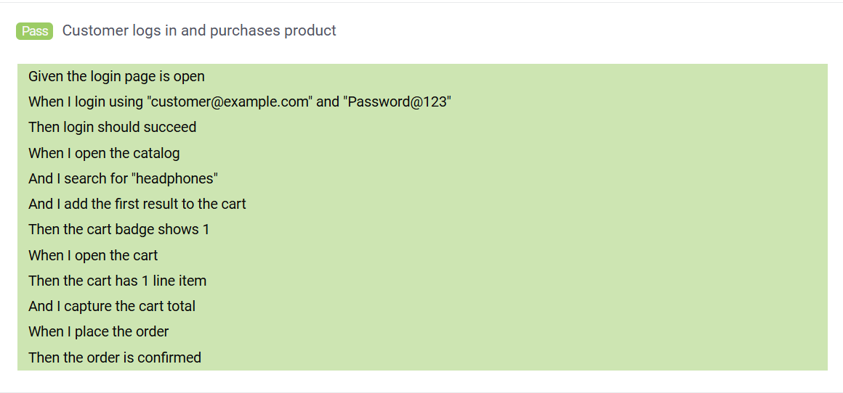

Negative Test Scenario
- Demonstrate Failure Evidence (@negative)
This scenario was intentionally created to fail in order to validate screenshot capture and reporting.
Search product -> Validate incorrect cart badge count

Expected:
Cart badge = 2

Actual:
Cart badge = 0

Result: Failed (As expected)

Purpose:
To demonstrate failure handling and screenshot attachment.

Screenshot Capture
Screenshots are captured automatically whenever a scenario fails.
This was implemented using Cucumber Hooks.
The screenshot is attached to the execution report to help identify failures quickly.

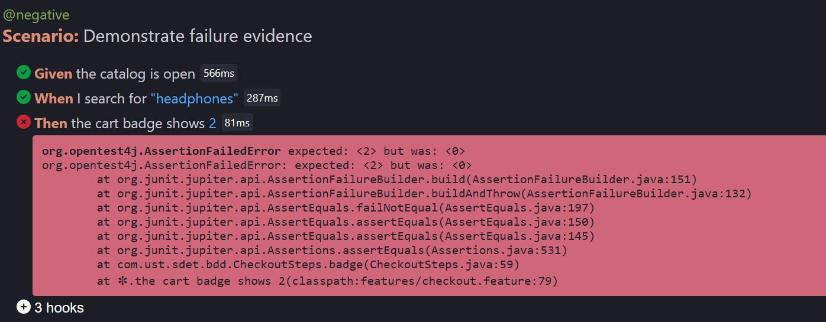

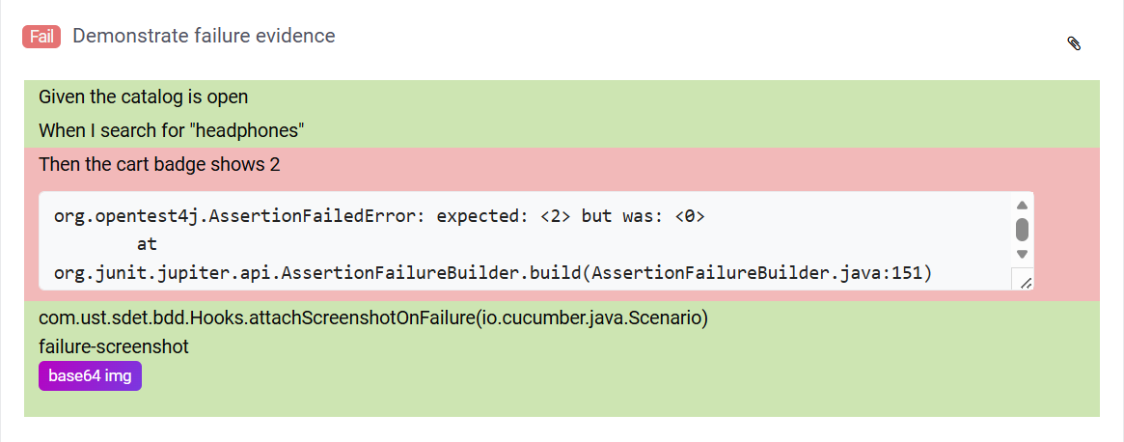
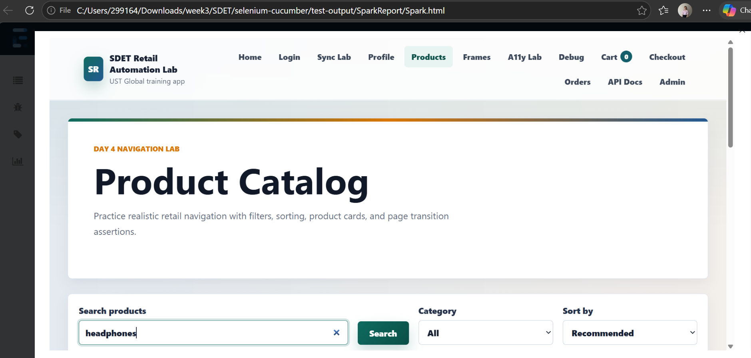

Reports Generated:

Extent Report:
Location:
target/SparkReport/Spark.html

Allure Report:
Location:
target/allure-results

Steps to run the project:

Run all tests:
mvn clean test

Run in headed mode:
mvn clean test -Dheadless=false

Run smoke tests only:
mvn clean test -Dcucumber.filter.tags="@smoke"

Run regression tests:
mvn clean test -Dcucumber.filter.tags="@regression"

Run end-to-end tests:
mvn clean test -Dcucumber.filter.tags="@e2e"

Run negative scenario:
mvn clean test -Dcucumber.filter.tags="@negative"

Run multiple tags:
mvn clean test -Dcucumber.filter.tags="@smoke or @e2e"

Screenshots:
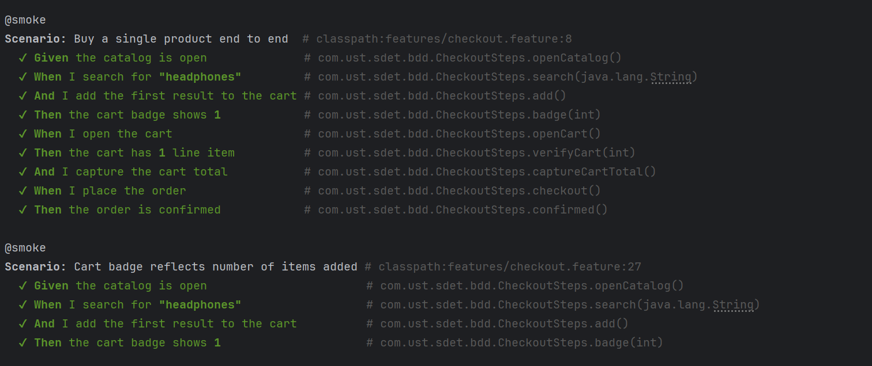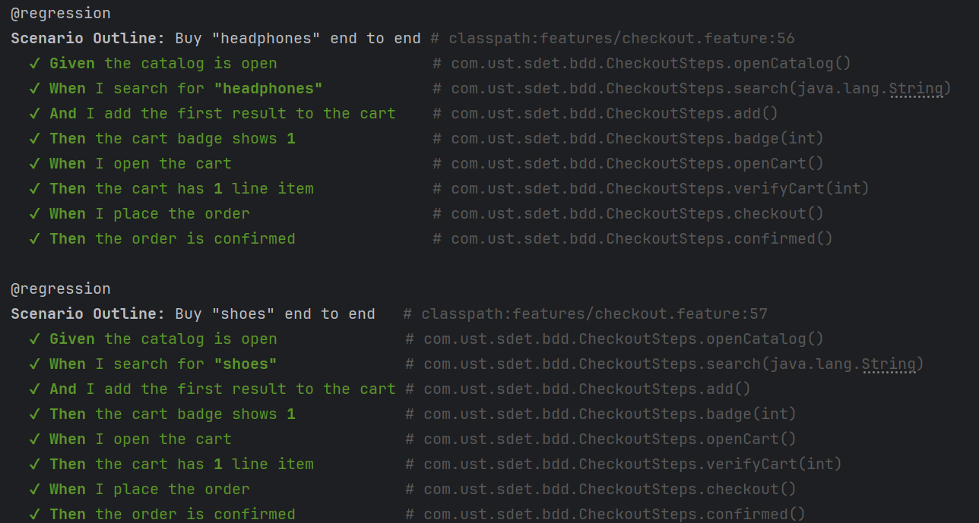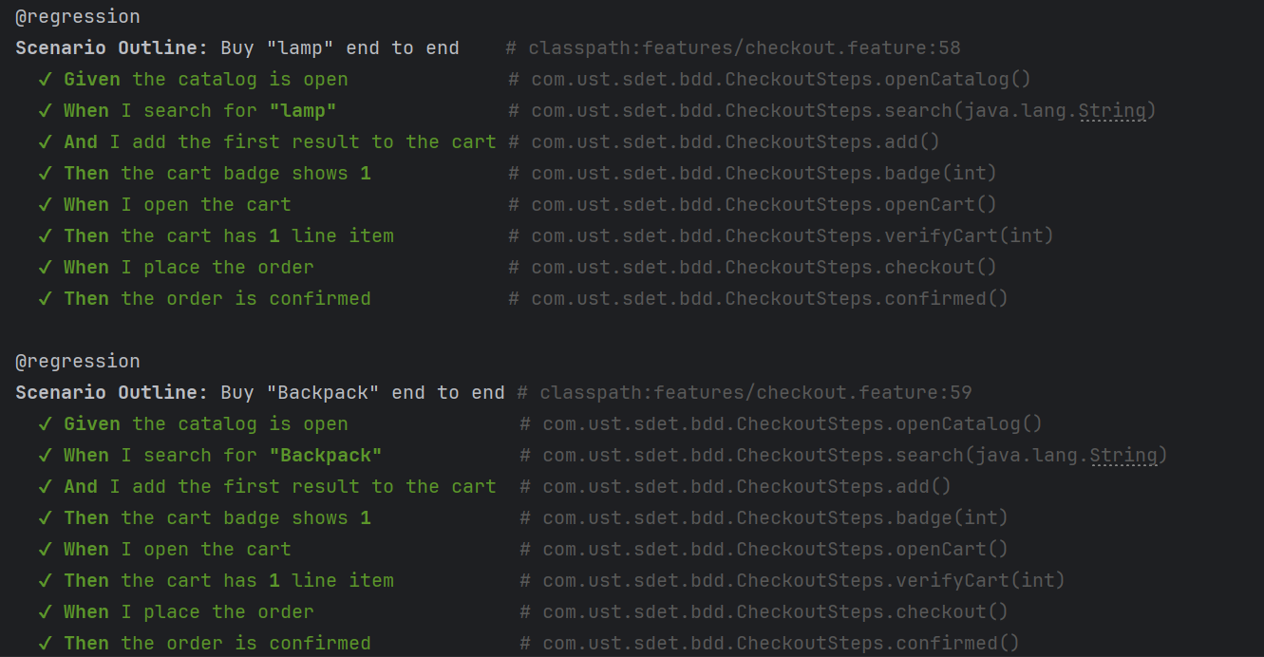
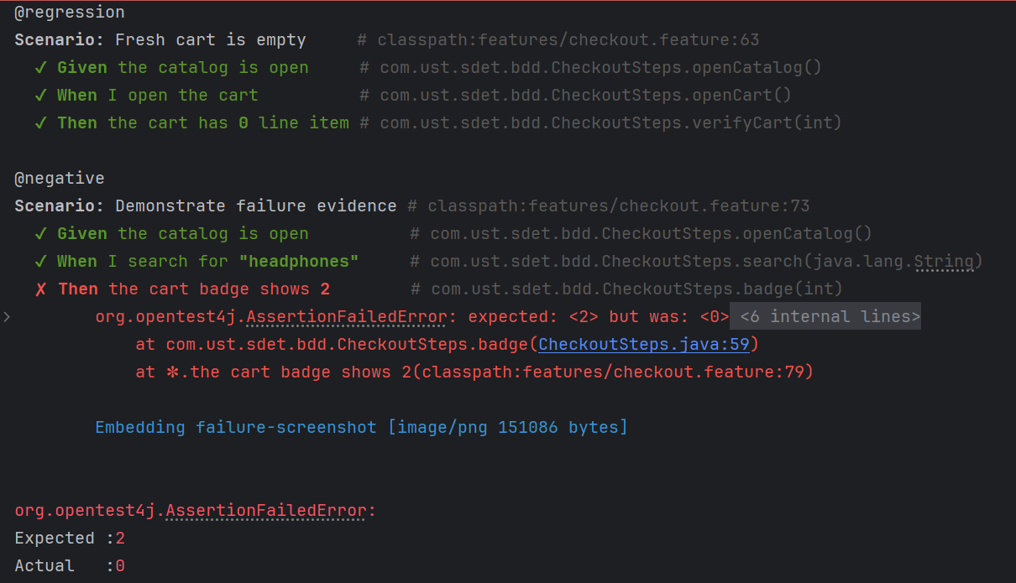
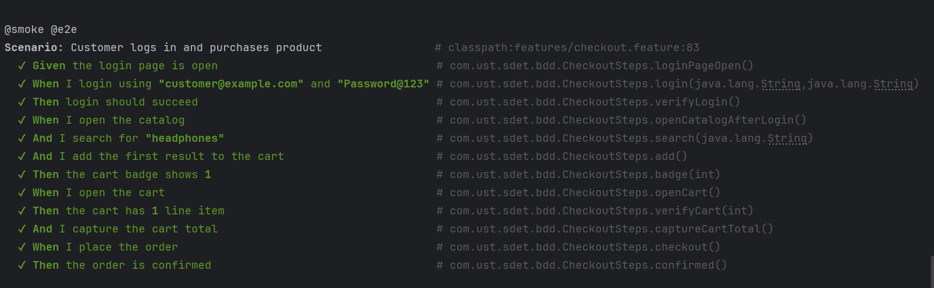

Conclusion:
This project successfully automates the retail purchase flow using Selenium and Cucumber.
The framework supports reusable components, tag-based execution, reporting, screenshot capture, and complete end-to-end testing while keeping the test code clean and maintainable.

